**MANAGING PROJECT SCOPE.**

As a project manager they should ensure that the project scope and goal as defined clearly at the beginning as changing later will change both.

Project managers when faced with something that lies outside the project scope or goal will use the triple constraint model.

Triple constraint model:

Is the combination of the three most significant restrictions of any project.

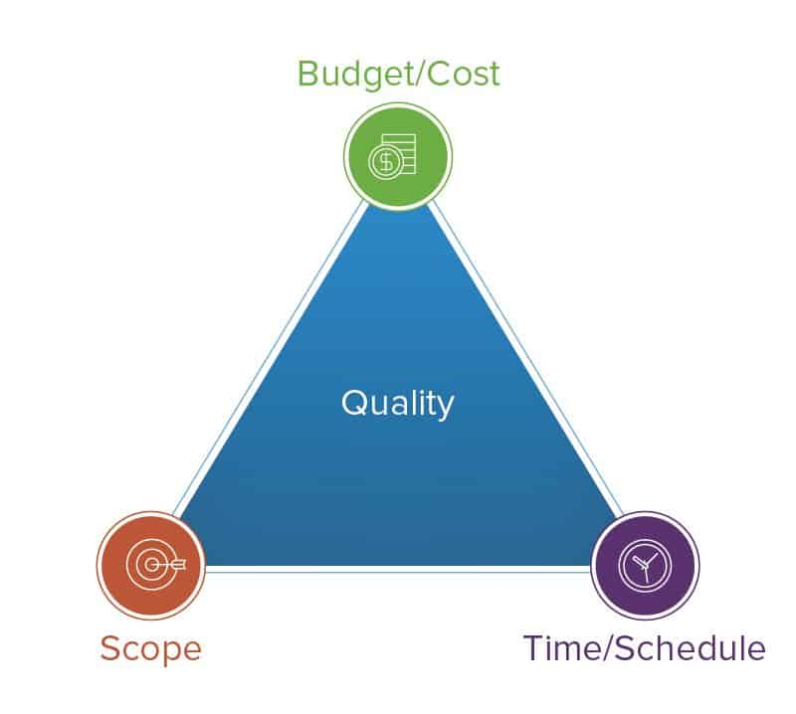

We mentioned what scope is, so when considering a change outside of the goal or scope consider the impact it has on the scope and time and cost.

Time: Project schedule and deadlines

Cost: Budget and resources.

Both must be carefully managed as to keep it inside and feasible of the project.

All three of these are linked, so when making a change to one you must consider the changes to the others.

As well understand what trade-offs you’re willing to make, to the scope, time, and money.

To do this you need a clear understanding of the project priority’s, for its time, cost or scope.

For example:

Then you can justify changes to the three.

If it must meet a specific deadline no matter what then changing scope or cost will be considered

If you need a specific thing to work no matter what, then chaining the budget and time will be considered

Just cause you can make a change doesn’t mean you have to,

Weighting off the trade-offs and undersigning the impact.

When a change is offered you must first know where the change lies, is it scope related, cost related or time related.

For example:

The plant pals bundle pots have feature show when to water them>

This is a product and service change, so it lies in the scope.

To make this change you validate It will stakeholders and sponsors, after agreeing on changing the scope, you must now consider the other two, you will then ask if the budget should change if not, then you increase the time and deadlines for accompanying the change in scope.

For example, if they say decrease the budget and keep the scope same, then that leaves time, so you increase the time.

For example, a decrease in time and no increase in budget, you would have to make changes to the scope, like relapsing with less features

Managing changes to scope.

Use the three main factors, cost, scope, time.

If one or two change then you change the remaining one to compensate.